# Amazon Simple Queuing Service SQS

## Steps

### Create FIFO Queue

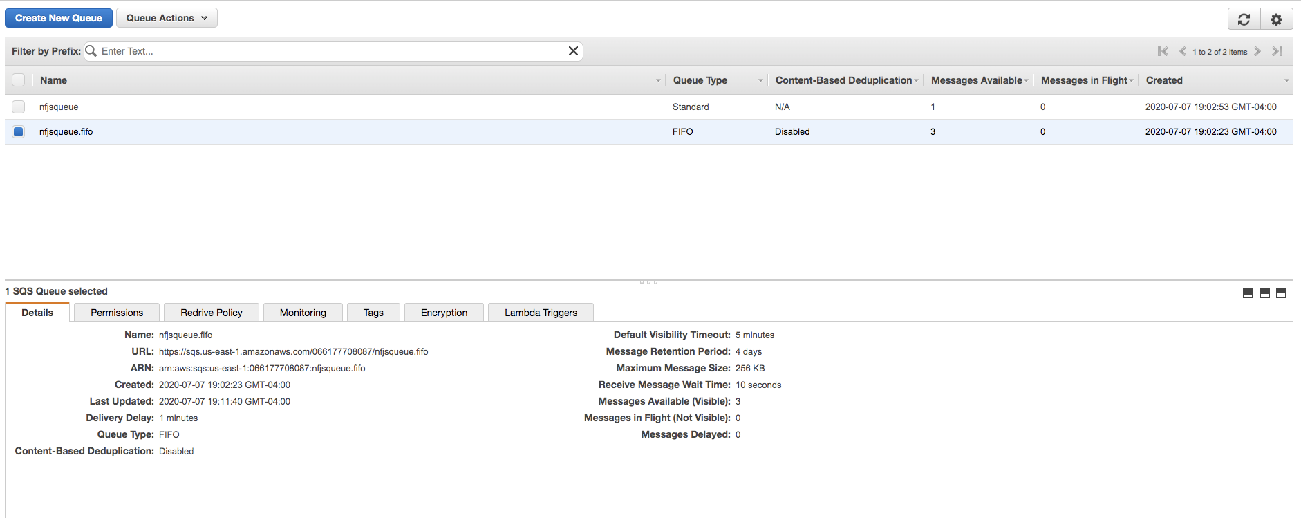

### Create Standard Queue

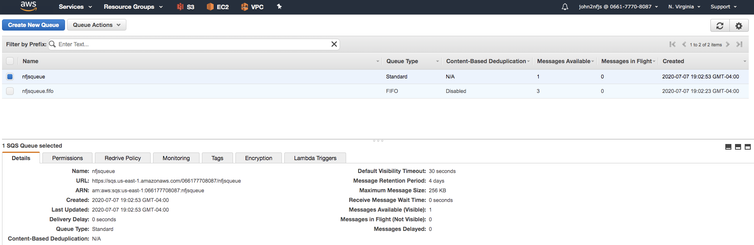

### Sending messages for FIFO

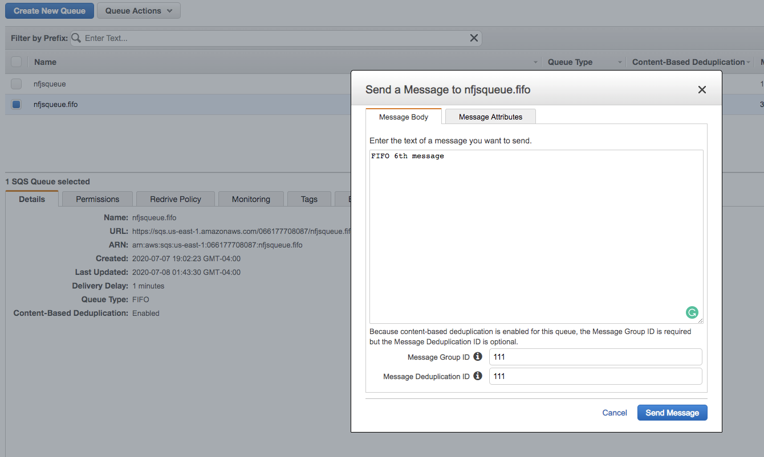

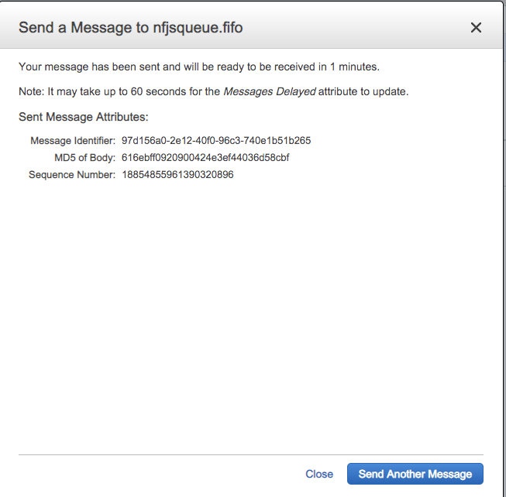

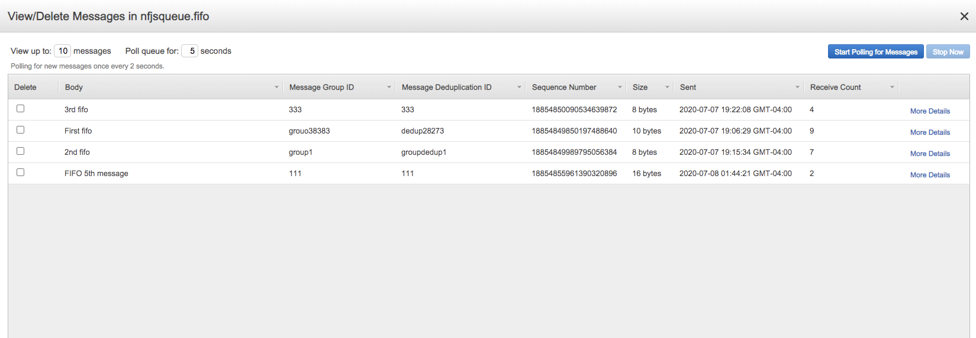

### Long Polling

WaitTimeSeconds argument to 1-20 seconds

**Long polling** is cost-effective because you're not constantly polling an empty queue

The maximum amount of time that a long polling receive call will wait for a message to become available before returning an empty response.

**Visibility TimeOut**

The length of time (in seconds) that a message received from a queue will be invisible to other receiving components.

**Delivery Delay**

The amount of time to delay the first delivery of all messages added to this queue.

